SCREENSHOTS FOR MACHINE PROBLEM 2(PYTHON)

**SCRIPT:**

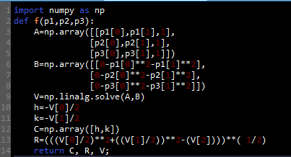

**OUTPUT:**

